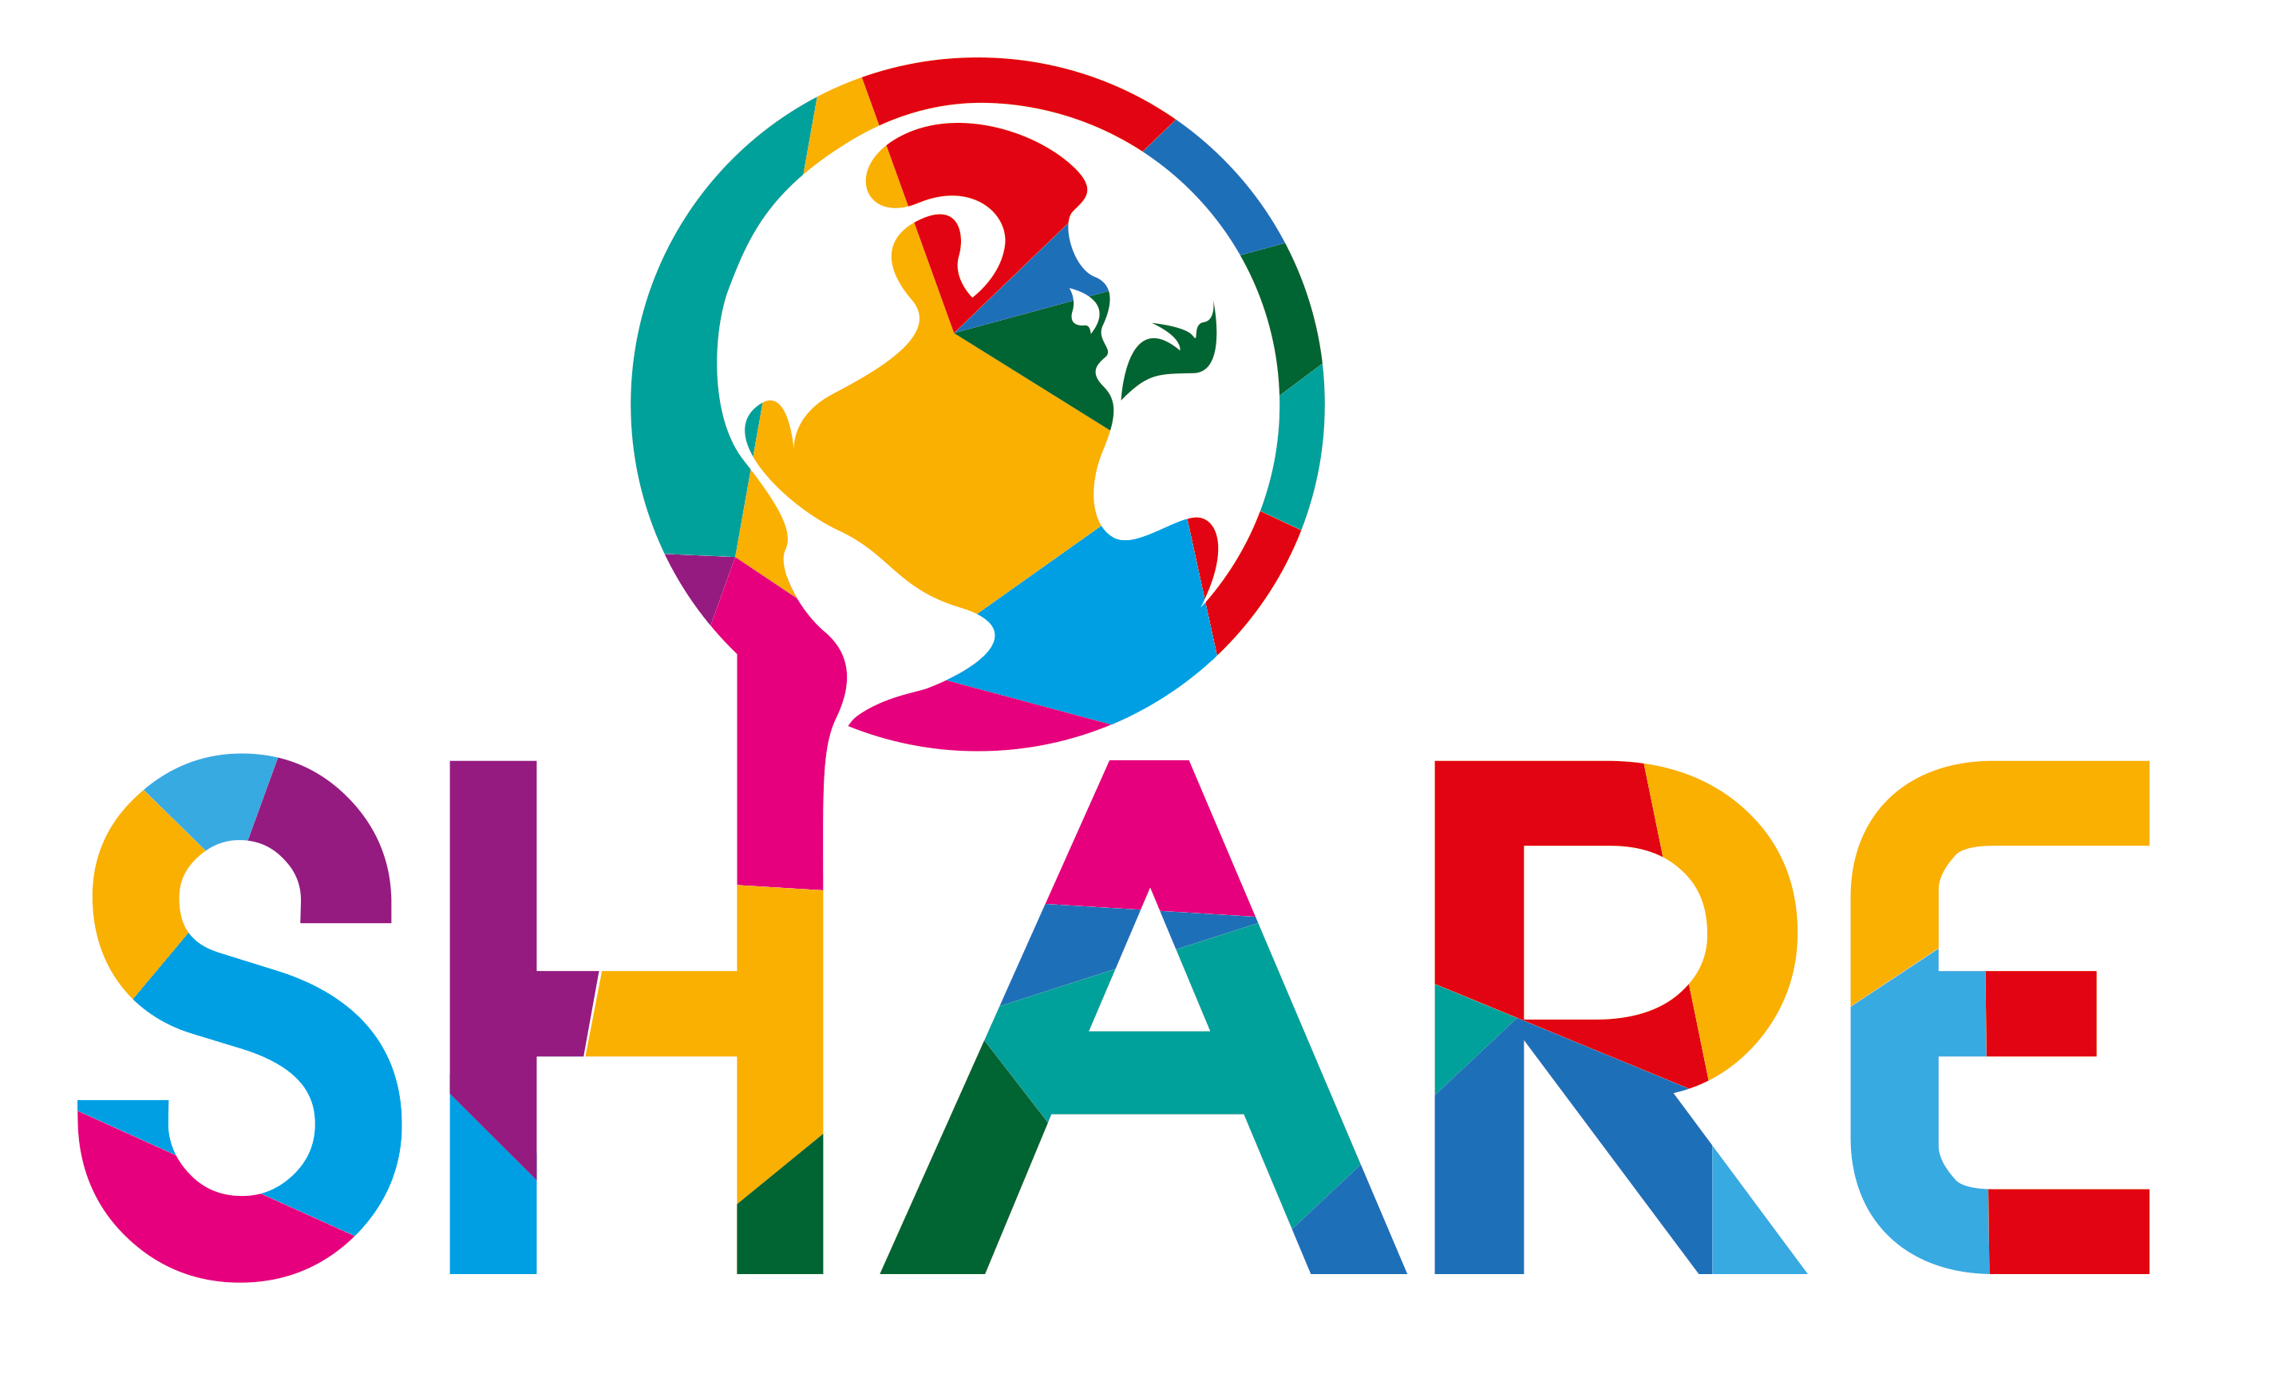
Easter Bake Sale
Wednesday 1st April, 2.30 – 4.30pm
Are you be able to bake Easter goodies for SHARE?
Volunteers are needed for:
Baking
Set Up
Selling of baked goods
Clean up
Are you interested in helping us raise money for SHARE?
Please contact Marianne Heemskerk at marianne@hartog.nl or sign up on the sheet posted in the Main Foyer near PTA room
All proceeds go to SHARE

